February 25th, 2007
Hi


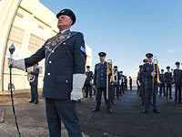
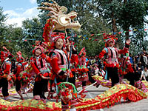
Last Sunday, the Chinese New Year parade was held in TST. It was something of an extravaganza with many floats, and performing groups from around the world. (The pictures on the right show a troupe from China, the Royal NZ Air Force band and the Jean Wong ballet school). I was not there but wanted to watch it on TV but gave up after most of the time seemed to be spent on advertisements!
Last Monday night, a fire works display was held above the harbour in spite of drizzle.
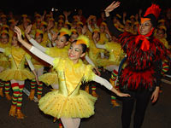
I have again been having some annoying breathing problems. I have had to take some stronger medicine in the form of (Nuelin) tablets. The breathing did not seem to affect my gym exercise but it did affect yesterday’s run and also kept waking me up in the nights.
I said last week I would cut down on skipping so I could do other exercise as well, but on one day ended up doing 30 min (8 + 22 min). Surprised I could do 22 min without a break. I was first only going to do 7 min to make a total of 15 min, but kept extending it bit by bit. Might have gone on a bit longer but decided a total of 30 min was enough.
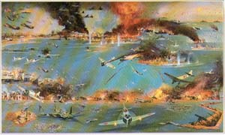
On Monday last, 65 years ago (1942), Darwin, Australia was attacked by the Japanese air force. That was about as far as the Japanese got. They were there for 21 months before the tide turned against them. The pictures on the left show a painting of the attack, an oil depot burning and a Mitsubishi bomber of the type used in the attack.
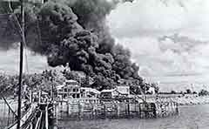
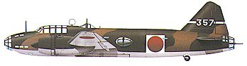

The Arthur Li affair is hotting up. He has sent a letter from his solicitor to Bernard Luk (my former colleague) and now Vice President of the HK Institute of Education threatening to sue him!
Last week, I forgot to say that Uncle Keith e-mailed me to let me know that our last auntie had died. She was Auntie Pat and lived in Wellington. She was Nana’s youngest sister. I am not sure if you ever met her though I have a feeling when we on the campervan holiday in NZ, we visited them when we were in Wellington. I am not sure how many uncles are left; one at least (Auntie Pat’s husband) and perhaps one other.
The run yesterday was not good due to breathing, though the last 30 minutes was OK. The time was nearly 2 hr 40 min though this is meaningless because of the breathing and also as it was partly a new route. The first part was from Tai Tong to the Tai Tam reservoir through the amusement park (the last leg of one our runs last year, Leonie, but in reverse). But going in the opposite direction is not always straightforward. I got completely lost in the amusement park having missed the turnoff, which looked quite different from this direction. Ended up in a ‘Bat cave’ at one stage. Also on the run, I needed to have a poo, the first on a run for several years. I always carry a length of toilet paper just in case of such an emergency!
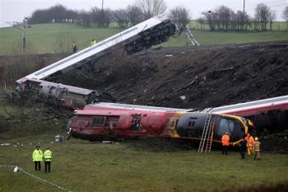
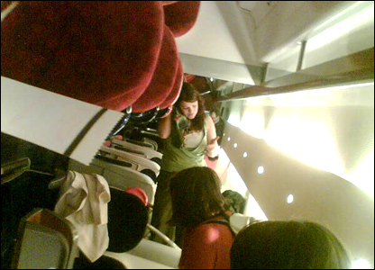
Next week I have two medical appointments. On Wednesday, it is just the regular follow-up at the hospital and on Thursday at the dermatology clinic. I forgot to mention that since coming off the ‘Aldara’ cream, my face has completely healed though there is still a slightly pinkish area. In addition, my appetite has returned and I do not get as tired now. This does not prove that the problems were caused by the cream, but I think they were.
Heard about the high-speed train crash in the UK. Amazingly, only one person was killed, which seems to be due to the train being and built like a tank in contrast to older trains. One picture shows a general scene of the crash and the other taken by a passenger of a carriage on its side.
A lot of Rugby this weekend. In Dublin, Ireland convincingly beat England in the Six Nations championship. This game was notable as it was held in a stadium where in 1920, during Ireland's fight for independence from British rule, British-led forces opened fire killing 14 protestors during a Gaelic football match. (The game was not held in the Irish Rugby stadium, which is being re-built.)
That’s about it for this time.

Cheers.

